**How to use Android native camera**

1. **Introduction**

This tutorial will help you know how use Android native (default) camera.

1. **When should you apply this?**

You should apply this when you want to use Android camera with all its options like zoom, turning …

1. **Advantages**

Easy and effective.

1. **Disadvantages**

Impossible to interfere while camera is running.

1. **Requirement**

Eclipse and emulator with SDCard support or real phone.

1. **Steps and Screen shots**

* First, you need to call the camera.

Intent cameraIntent = **new** Intent( android.provider.MediaStore.*ACTION_IMAGE_CAPTURE*);

* Then save the photo you just took in SDCard

cameraIntent.putExtra( android.provider.MediaStore.*EXTRA_OUTPUT*, android.provider.MediaStore.Images.Media.*EXTERNAL_CONTENT_URI*);

* Remember to add this in your manifest files:

<uses-permission android:name=*"android.permission.CAMERA"* />

<uses-permission android:name=*"android.permission.WRITE_EXTERNAL_STORAGE"* />

* UI of native camera:

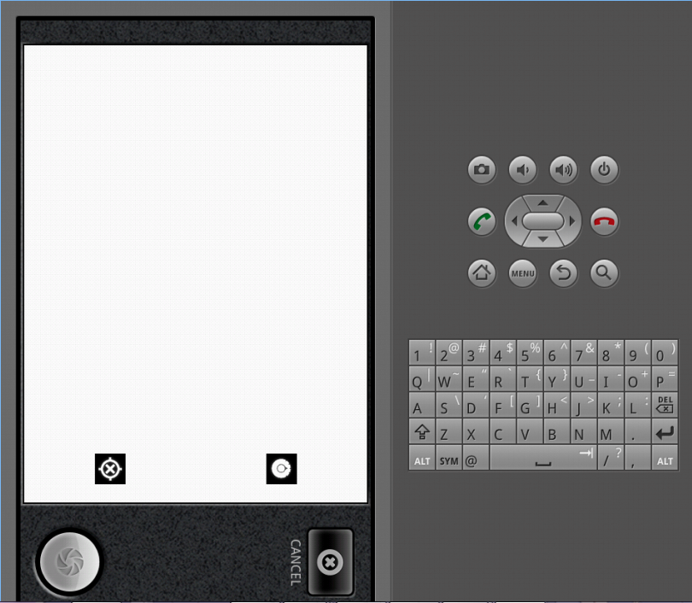

1. **Reference**

<https://github.com/lorensiuswlt/AndroidImageCrop>

Contact me if you have any question: bachxvu@gmail.com